Vision-Based Autonomous Smart Car Redesign for Reliable Navigation

Team Member | Student Number
Evan Romano | 251327329
Joseph Toma | 251283541
Mohammed Alamen Qassab | 251285296

Project Overview
The objective of this project is to redesign and improve an existing smart robotic car platform by addressing known mechanical, electrical, and safety deficiencies while extending the system to support vision-based autonomous navigation. Building on the original Smart Car Redesigning Project, our goal is to produce a more reliable, robust, and functional platform that is capable of navigating an obstacle-filled track using onboard sensing and decision-making.
The project maintains the original intent of improving system reliability and safety, while integrating a camera-based perception system that enables the car to detect obstacles, interpret its environment, and make navigation decisions without manual control.

Project Objectives
By the end of the project, we aim to achieve the following:
- Eliminate known mechanical failure modes in the head gimbal and chassis design
- Improve wiring reliability through proper routing and strain relief
- Implement a safer and more robust battery and power management solution
- Design and integrate a vision system capable of detecting obstacles and guiding navigation
- Produce a fully functional smart car platform suitable for repeated testing and future extension

System Description
The redesigned vehicle will operate on a closed track with obstacles placed in unknown locations. An onboard camera will be used as the primary perception sensor. The camera system will provide real-time image data to the onboard processor, where computer vision techniques will be used to identify obstacles and relevant track features.

Camera Functionality
The camera functionality will include:
- Continuous image acquisition during vehicle operation
- Image preprocessing to improve detection reliability
- Vision-based obstacle detection to identify blocked and free regions
- Marker detection to identify a designated endpoint
The processed visual data will be used by the navigation logic to guide steering and speed commands. Rather than implementing a full-scale mapping or SLAM system, the project will focus on a simplified internal representation of the environment appropriate to the platform's scale and constraints.

Mechanical & Electrical Redesign
The project explicitly addresses the known deficiencies of the existing smart car platform:
- The current gimbal design suffers from cantilever loading on servo shafts. This will be addressed through a redesigned mounting approach.
- Wiring failures caused by repeated motion and lack of strain relief will be mitigated through improved cable routing, mechanical support, and proper strain relief at connection points.
- The use of unprotected 18650 cells will be addressed by incorporating a safer battery solution and appropriate power management.
- A stronger chassis design will be implemented to reduce damage when the car is accidentally driven off elevated surfaces.
A custom PCB will be designed to integrate power regulation, motor control interfaces, sensor connections, and processing hardware.

Team Responsibilities
- Mechanical Design and Integration: Mohammed Alamen Qassab
  - Chassis redesign, gimbal mounting, battery mounting, and mechanical protection of components
- Electrical and PCB Design: Joseph Toma
  - Power management, motor interfaces, wiring layout, and PCB schematic and layout
- Embedded Software and Control: Mohammed Alamen Qassab
  - Motor control, sensor integration, and system-level coordination
- Vision and Navigation Software: Evan Romano
  - Camera integration, image processing, obstacle detection, and navigation logic
Responsibilities may overlap as needed, but each subsystem will have a primary owner to ensure accountability.

System Block Diagram
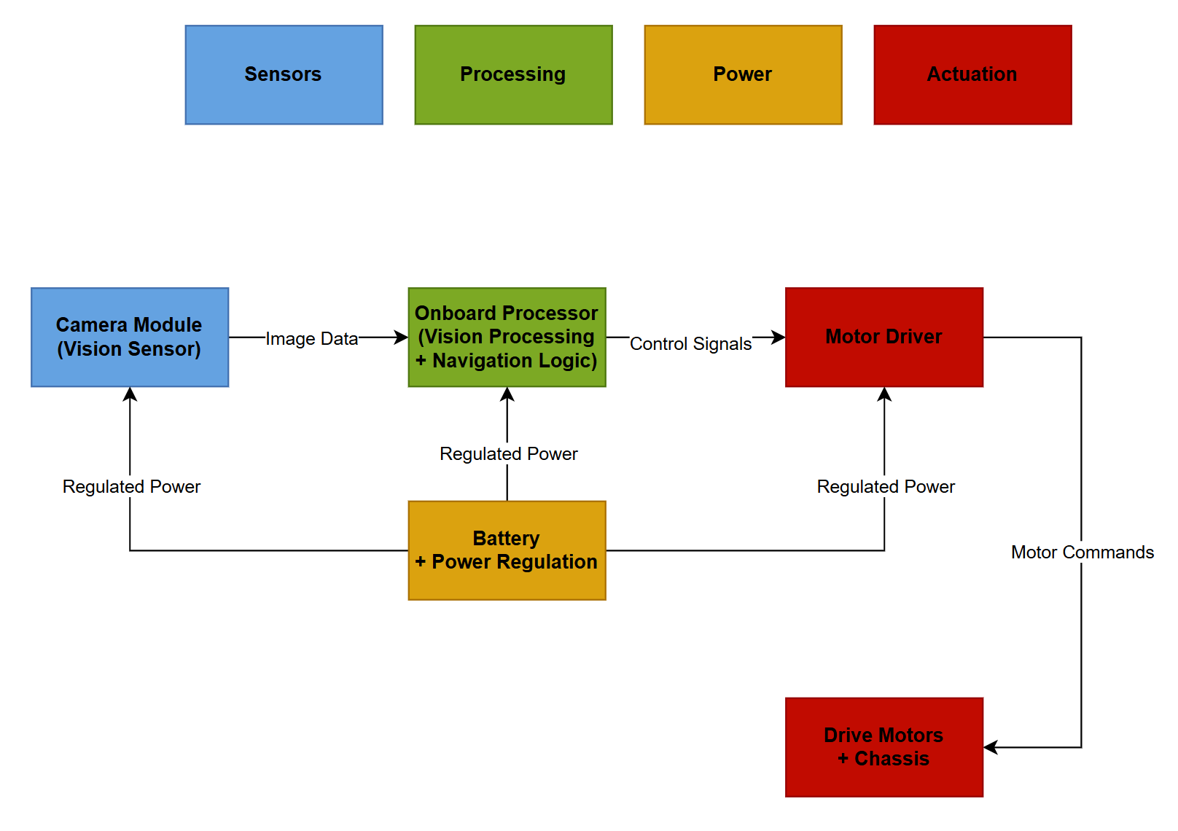
Figure 1: High-level system block diagram showing the interaction between the vision sensor, onboard processing, power system, and motor actuation for the autonomous smart car.

